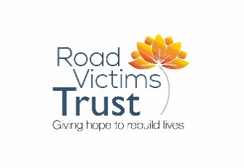 | Road Victims Trust Training Programme 2025  Venue: Stevenage TBC  Please note – the final Saturday is online and the final Wednesday evening is in-person  100% attendance is required
Module 1 Loss and Bereavement
Wednesday 26/02/2025 LH/JC/VR |  | Saturday 01/03/2025 LH/VR |  | Wednesday 05/03/2025 JC/VR
Start 18:30 |  | Start 10:00 | Start 14:00 | Start 18:30
Introductions |  | A personal perspective | Individual factors | Sudden death
Course Outline |  | ‘Good enough’ support | Grief – Theory | Trauma – theory
Life’s Losses |  | The impact of loss | Complicated grief | Road death
Live on Zoom |  | Face to Face |  | Live on Zoom
End 21:30 |  | End 13:00 | End 16:30 | End 21:30

Module 2 Road Death
Saturday 08/03/2025 JC/VR |  | Saturday 15/03/2025 LH/VR
Start 10:00 | Start 14:00 | Start 10:00 | Start 14:00
Road death | A family experience | Police | Prosecutions
Collision |  | Coroner | Courts
Face to Face |  | Face to Face
End 13:00 | End 16:30 | End 13:00 | End 16:30

Module 3 RVT Service
Saturday 22/03/2025 LH/JC |  | Wednesday 26/03/2025  LH/VR | Saturday 29/03/2025 LH/VR JC? |  | Wednesday 02/04/2025  LH/VR
Start 10:00 | Start 14:00 | Start 18:30 | Start 09:30 | Start 14:00 | Start 18:30
The service | Preparation | Working in an unknown Space | The session | CV experience | Summary
Case study | Visiting |  |  |  | Losses on ending
Face to Face |  | Live on Zoom | Live on Zoom |  | Face to Face
End 13:00 | End 16:30 | End 21:30 | End 13:00 | End 16:30 | End 21:00

